How to upload and link files (like exercises or student assignments) to Clilstore.

Login and then create a unit in Clilstore and click “Publish”
Leave the unit and test it in Clilstore
Click the pencil icon to edit the unit

You can now see a new button labelled “Files…”

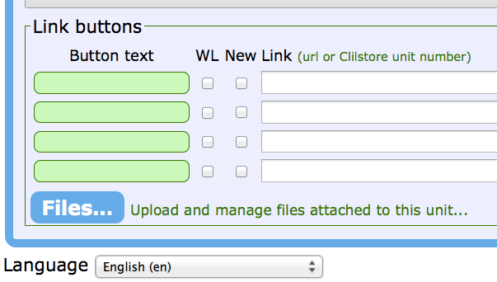

Click the button “Files…” and you come to a new option:
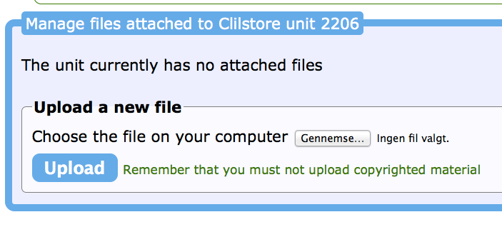
Click the button for “Choose the file on your computer”

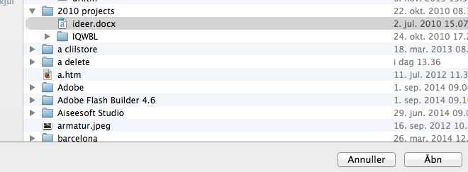
Select the file you want to use in Clilstore and click “Open” (In Danish “Åbn”)

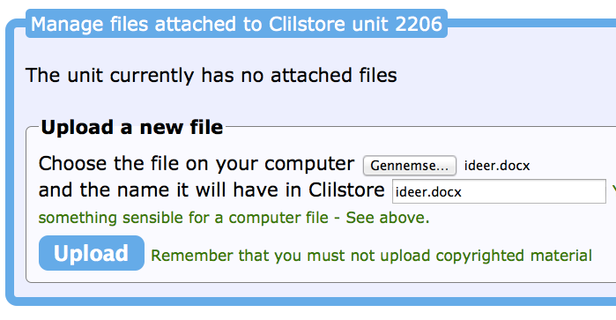
Then click “Upload’ so the file is sent to Clilstore

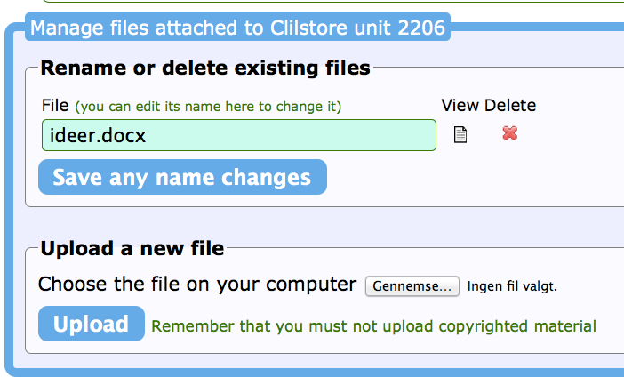
The file has now been uploaded, you may now rename it if need be and then click “Save any name changes”. You can also choose to delete the file

If you only needed one file such as a Word file (e.g. ideer.docx as used in this example”) then the next step is:

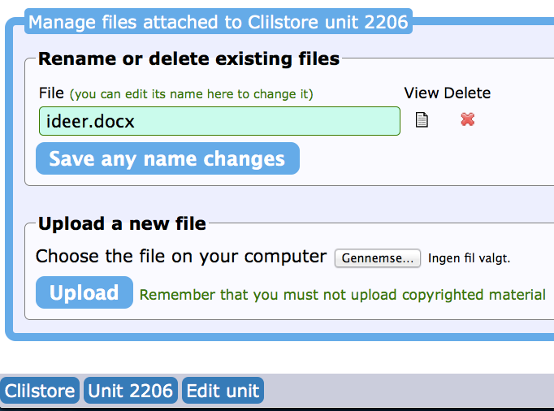
Click the blue button labelled “Edit unit” below the upload file frame

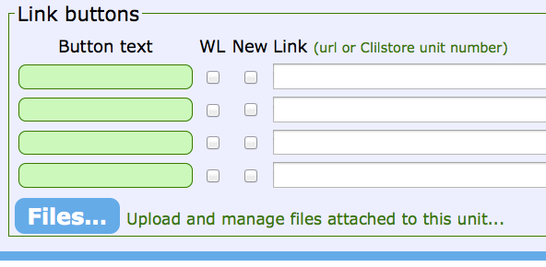
You are now back to the edit page with the “Link buttons”

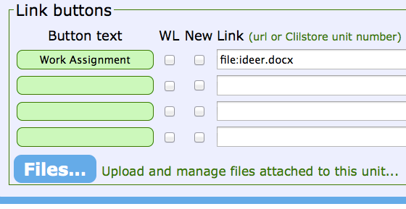
Write a text in the “Button text” and in the white field next to that write
“file:ideer.docx” or if you file was called “assignment.pdf” you should write
“file:assignment.pdf”

Finally click “Save unit” and when you go to the unit you will see a button with your text which links to the file:

That was the simple part, but what about a sequence of exercises made in Hot Potatoes?

Uploading and linking to a sequence of exercises made in Hot Potatoes.

You should always save your Hot potatoes exercises in a new folder so you know where they are and have tested that they work perfectly on your computer before uploading to Clilstore

It is strongly recommended that after you have made the exercises you make use of “The Masher” in Hot Potatoes to save your files in the new folder with a menu file, which will usually be named “index.htm”

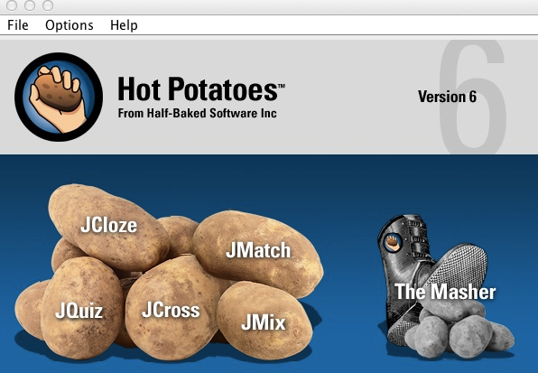

In this example I have used The Masher to make three Hot Potatoes units and the menu file, all four files now end with “.htm”. It is those files that have to be uploaded to Clilstore:

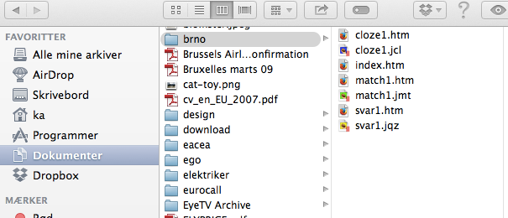

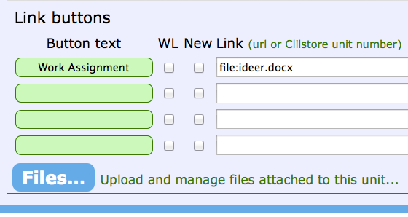
As in the Word file example go to edit and click “Files…”

Then repeat the steps below for all the files one by one; you can only upload one file at a time to Clilstore.

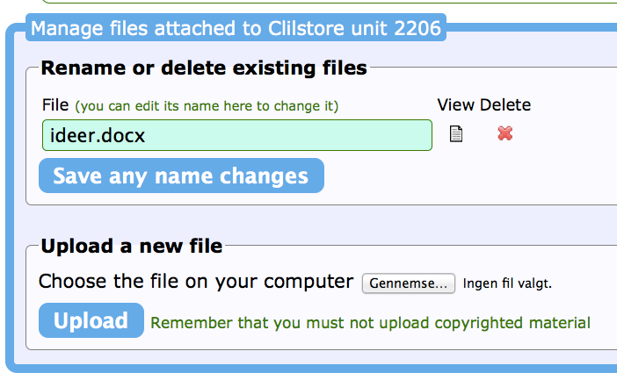
Click the button for “Choose the file on your computer”

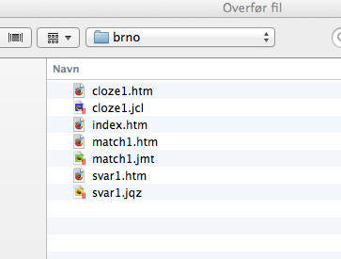
Select one of the files ending with “.htm” and click “Open”

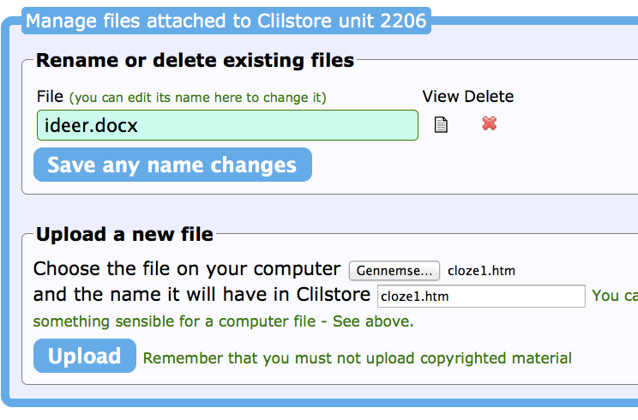
Click Upload (but in the case of Hot Potatoes exercises you should NOT rename a file as that will ruin the menu)

Repeat the above until all (in this case four .htm files) have been uploaded
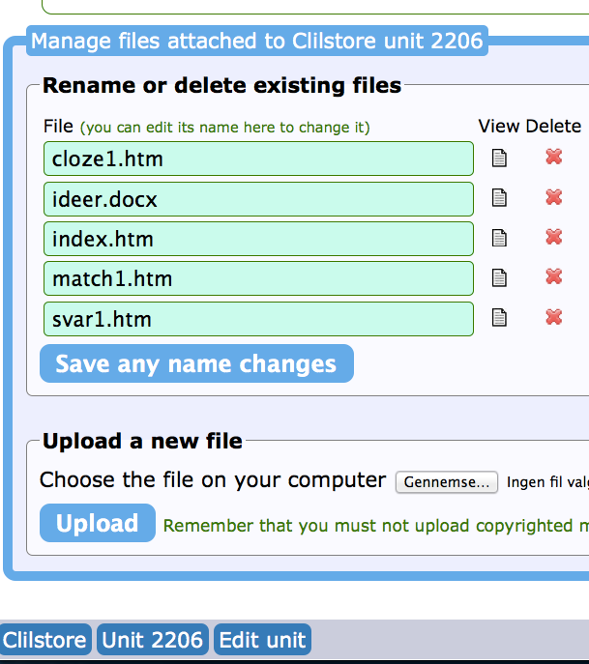
Click “Edit unit” after uploading all the .htm files

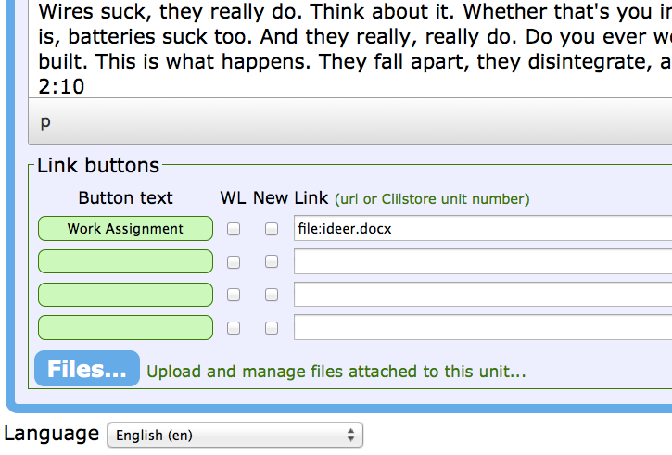

Finally it is time to link to the menu file titled “index.htm”

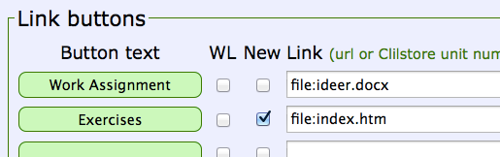
Type in some text in the green box
Type in “file:index.htm
I have chosen to open the Hot Potatoes exercises in a new tab/window by clicking the “New” box

Finally click “Save Unit” and:
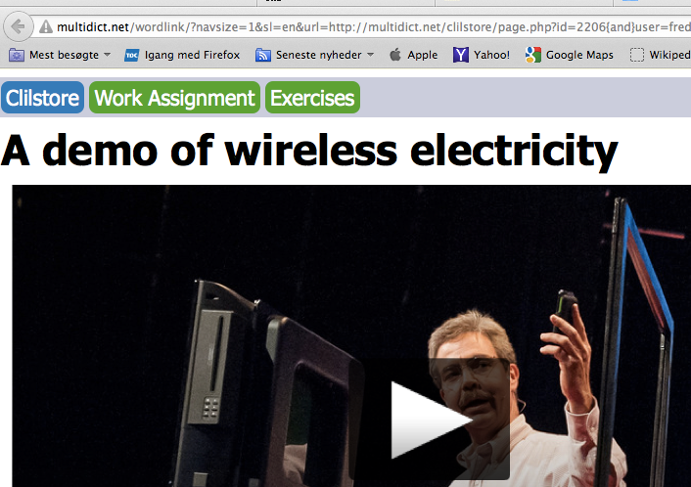
The unit now links to the Word file and a menu with the Hot Potatoes exercises:

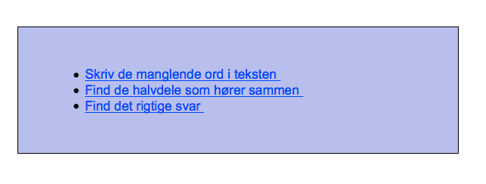
You can learn about Hot Potatoes from the Hot Potatoes website: https://hotpot.uvic.ca/ and watch some demo videos from:
http://languages.dk/pools-3/index.html#Pools-3_Do_It_Yourself_videos BUT the demo videos do not show the use of “The Masher” which produces the menu file.

